|  |  |  |  |  |  |  |  |  |  |  |  |  |  |  |  |  |  |  |  |  |
| --- | --- | --- | --- | --- | --- | --- | --- | --- | --- | --- | --- | --- | --- | --- | --- | --- | --- | --- | --- | --- |
| **Software Implementation Project Title: EntreCoore**  **Project Group Members:**   |  |  |  |  | | --- | --- | --- | --- | |  | **Student ID** | **Name** | **Overall Contribution(%)** | | **1.** | **1731920** | **Aylin Görgün** | **%34** | | **2.** | **1731844** | **Bahri Kaan Beşik** | **%22** | | **3.** | **1806499** | **Betül Fatma Erkoç** | **%22** | | **4.** | **1608706** | **Hakan Erenler** | **%22** | |

**Project Management:** (Explain the tasks involved in the project, their durations, and how much each member contributed. Gantt Chart output the work package should be included in the project and the work package activities included in each work package should include the planning of time and responsibilities.)

We had four main tasks. Mobile development, web development, chatbot and designer and social media manager.

Aylin coded the Mobile application using Flutter. She managed http request to get the news page, deal with API’s used firebase and firestore cloud for managing users, Sqlite for CRUD cycles, date formatters, tried to developed efficient algorithms for mine sweeper and used various UI components such as listviews, listtiles, builders, cards, checkboxes, buttons, tabbars, drawers, floating action buttons, and hamburger menus. Also managed our Github, Trello and Discord accounts, which we used for communication and sharing.

Betül is our web developer. She mainly used vue.js which is a very new javascript framework. She assessed pros and cons for using vue.js instead of html, css, and jquery. After starting developing she compared Bootswatch, Vuetify and BootstrapVue. She also setup a connection with Firebase for proper authentication. Used Vuedraggable for her tables. And created CRUD cycle for notepad parts. Used components like textboxes, routers, navbars and draggables.

Kaan is our developer for chatbot. He did his first attempt with using python but unfortunately that wasn’t a succesfull attemp because considering that short amount time, processing that much data wasn’t a good decision. So, he switched to DialogFlow alongside with vue.js. Created nodes which leads user to various answers.

Hakan is our designer and social media manager. He designed our logos and icons. Followed material design standards for android and Cupartino standarts for IOS. Also, researched Web design standards. Made decisions about our color palette. He also created our Facebook, Twitter, Instagram and Youtube accounts. Created and shared regular posts. Used tools like Adobe and Sketch. Also made our video using Final Cut.

We used Github as our workspace so you can see our detailed commit history in here. Also our design props folder you can see our designs. But we are also attaching our plan as a blueprint. And our flowchart is in the end of the file.

|  |  |  |  |  |  |  |  |  |
| --- | --- | --- | --- | --- | --- | --- | --- | --- |
|  | User Adjust. | Boards | Reminder | Reading | Notepad | FunZone | Chatbot | Social Media & Design |
| Aylin | **X** | **X** | **X** | **X** | **X** |  |  |  |
| Betül | **X** | **X** |  |  | **X** |  |  |  |
| Hakan |  | **X** |  |  |  | **X** |  | **X** |
| Kaan |  |  |  |  |  | **X** | **X** |  |

**Abstract: (**This section is the short summary of your project.The idea of the project, how to project will be implemented in real- life, and the methods used for modeling, simulation, testing, prototype production etc. explain the validation methods and the expected / expected results. Approx. 400 words)

Our software helps people to organize their studies. Basically, it has three platforms to operate: Android, IOS and in the web. While mobile applications are created with Flutter, the web part of the project was created with vue.js. When we designed the app, we tried to answer just one question: What an entrepreneur need? And what can we do to increase their creativity? First, users should create an account with e-mail and password. In order to keep their data, we used firebase which supports both mobile and web platforms. Thus, users can easily login all applications when they have an account.

In mobile part you can take notes, read news, make todo lists and give them details, also you can play mine sweeper game to have fun. In the web part, when users log in, they have two opportunities: Reading news or creating to-do lists. In that way, users can follow the news while they organizing their task. Moreover, users also can create notes in the mobile application. They are able to update and delete the notes when they need. On the other hand, the web part of the project has similar features to the mobile application. However, there is no news section for web users but they can create notes and tasks for to-do or doing or done lists. Thanks to the vue.js's draggable component, users can drag and drop their tasks easily and they are able to see where they are at in the studies on that time.

Also, we have a chatbot which was created with Dialogflow. Main vision about Chatbot is that a Chatbot which everyone can talk about any topic and it can do some tasks for you. Second part about chatbot is that, it could do some tasks like if you bored, it could tell you a joke or if you stuck in your code it could suggest some solutions or give information about the topic.

All in all, it is a great platform for users who eager to organize their tasks. And it gives you the power of both web and mobile platforms, all tasks can be controlled at any time and no matter users are.

**Methods Used in the Project and Implemented Product: (**In order to realize the project idea, the solution, the path, the tools, techniques and methods used should be explained. This section is also expected to include activities to verify or validate project outputs. Provide screenshots of the final product and explain the details about the flowcharts. Approx. 800-1000 words)

MOBILE

In mobile development part we used Flutter. As we mentioned earlier Flutter is a great IDE for cross platform applications. It is basic, beautiful most importantly it is fast. We preferred Flutter instead of React Native because it is much faster and has a great community too. We are welcoming you with our login page. It is powered by Firebase. Firebase_auth is the library’s name and we installed from the Flutter’s library called Dartlang. If you don’t have an account, you can created one too. Firebase has a method called _createUserWithEmailAndPassword and makes everything easier.

We used state-based structure for managing our authentication stage. Everything is connected to the root page directed from here. We also implemented validation methods. You have to enter something in both password and email fields. If you don’t we show you an error. Also, these somethings must fit Google’s email and password standards such as your password must be at least six chars. You can simply check all of these with writing a validator method and use as a filter before saving the user such as onSaved => (val) your text.

After successful login you will see to tabs. One for reading the news one for your todo lists. Let’s start with the news page. We created this page because as an entrepreneur you have to keep up with the news and plan your day accordingly. We fetch the news from NewsApi. NewsApi gives you a specified api key and with this key you can access to the [“articles"]. Articles has few attributes we used author, published-at, title and the description. All of these returns to a json of course. And related library in Flutter is url_provider. All of these news is displayed in List and Cards as an list items. And we are using list builder to keeping data index. Keeping data index is very important because after you click a news card you’ll be directed to another page which will show you the details about the news. And be able to understand which news you are accessing we had to keep the index. In details page we are also fetching image-url attribute and converting json to an actual image using Flutter’s Image.network widget. Our second tab in tabbar is todo. Also comparing with the native android tabs are not fragments. In Flutter you can implement anything in anywhere this gives you a lot of flexibility. In todo tab there is an empty list view and you can add listtiles. Those tiles are your todo list items. We are keeping them using sqlite (Sqlfite in Flutter’s library). In backend we have predefined list tiles called model which has a title and creation date. Basically, if user wants to add a list tile he/she just filling those fields. About creation date field, actually it is not up to the user’s choice it is filled automatically according to phone’s date. Of course we are converting it using Flutter’s date.format widget. Later on we are thinking to implement a timer for your cards so you will be able to set a deadline for your card. List tiles includes all of the CRUD circle. Create read update and delete. Most beautiful part is you can double click a card and add checkboxes. So, you can also enter details to your cards.

Above our tab bar there is a floating action bar for your notes. It is also a crucial feature for an entrepreneur. Working principle is same with the todo list, it uses a CRUD cycle. We choose sqlite because Firebase’s Firestore will be cost so much. But later on we are planning to create a backend our own for connecting with our web platform. In notepad section date formatter showing just the day. It works like this if you want to convert the whole thing you should use date.format(EEE for days, MMM for months and YY for year). Each letter stands for shown letter for example if you format as EEE you will see Mon for Monday.

You can also see your notes as list. Our update function implemented differently too. In todo page you should have long press to update, here we have a icon to delete. This offers you simplicity as all notepads should be.

In Flutter, AppBar has an attribute called drawer. It is the same thing with the Navigation Drawer in native-android. Drawer has userAccountsDrawerHeader attribute. We fetched network-image as background image. AccountsDrawer also have childrens: accountName, accountEmail and accountImage. As we mentioned earlier we are keeping our users in Firebase so our users is a collection. Method currentUser returns a Future<String> if you convert to string using to. String you can show accountEmail in the drawer as we did. This whole process is a preparation for user settings page. In this page you’ll be able to chance your picture and username. Why you should have those? Because also soon you’ll be able to add friends for working on the same cards. In our drawer you can also logout.

There is something worth to mention. In our drawer there is a list tile called Fun Zone. This tile navigates you to a mine sweeper game. Before we started this project, we targeted an app which contains all the essentials for entrepreneurs and having fun is one it. So, mine sweeper is basically two-dimensional array which has randomly positioned mines in it. Every element, let’s say boxes has a non-transparent cover. So, you don’t know where is the mines. As long you don’t click on a mine-box cover will pop and show you a number. This number will help you to determine where the mine is. In code-wise first we are randomly putting the mines and with the help of the loops we determine the numbers. Distance between mine and the box is the number we are showing to you. Also of course you can flag the boxes. Flagging makes the box unclickable. Determining user’s win or lose, again we are using states. There is also a timer to show you how much time did you spend as seconds.

WEB

The web part of the project, we mostly used vue.js which is a javascript front-end framework. First, all dependencies were installed and the project was created by means of command prompt. Then, we chose a theme from Bootswatch which offers different bootstrap themes. Subsequently, we created Sign Up and Login pages, and linked the firebase to our project. So that, users can access both web and mobile applications with the same accounts [28].

Then, we created other components like Board, Notes, Menu, and TaskItems. After generating templates and scripts for all components, we set up the router properly. Also, we installed Vuex to store and modify our data for components. Then, we needed the draggable property for the Board page to allow the users to drag their tasks between the cards. We installed also vuedraggable component. Thus, user can create task and update it's state by dragging when they want [29]. Also, in Notes page, users can create new notes and list them.

DESIGN AND SOCIAL MEDIA

When we are purposing (designing) the logo, we preferred using the applications of photoshop and adobe illustrator since these applications that allowed us to do whatever we imagined. If our creditor chooses another application to create this logo, it would be Corel draw. When we were creating and designing the logo, we focused on some features like catchy color and being simple. The color was designed as dark blue and light red by our creditor. We choose red since it draws attention and indicates how powerful it is. Also, the Word “Kanban” firstly used by Toyota and since Toyota is Japanese brand we can say Kanban invented in Japan. So, we influenced from the Japanese flag. At the same time, text font had to be seen innovative due to our IDE Flutter and framework Vue.js because they brought innovation.

We issued the power of social media That is prepared also as innovative as it can be. We choose all the materials that are necessary according to material design and Cupertino standards and applied them in our designs. Also, we prepared video to show users how it should be used. Final cut was used as a program for the video. Final cut includes a very powerful library and up to date interface.

**Literature Review**: (Provide proper citations to the references in your literature review based on IEEE citation style. Explain everything in your own word. Please keep in mind that these types of reviews take almost 2-3 pages with at least 10-15 references. Approx. 400 words)

PS: We used the Literature Review from our first proposal.

In order to make things easier to understand we are dividing our application to parts. Such as:

Board system, reading section, reminders, notepads and chatbots.

Probably the best way to explain what we mean saying board system is looking the idea behind it. The word ‘Kanban’ invented in the late 1940’s by Toyota. Kanban method is an answer for how to communicate with the group members, prioritizing your assignments, focusing and increasing productivity. The exact meaning is ‘better communication through visual management’ [LeanKit, What is Kanban, A Very Short History Of Kanban]. Simply if you write all of your assignments to separate post-its and stick them to a place which can be seen by everyone in your group is making a kanban. With digitizing world, we replaced post-its with e-kanban software such as Trello, Airtable, Asana, Avaza, ClickUp, KanbanTool and Yalla. So, let’s take a look at each one of them.

Airtable gives you ‘a view for every work style’ [<https://try.airtable.com>]. It has ios, android and desktop platforms also but as a user, if you are not working with very big and very crowded group it feels like you are not doing enough work and it affects your motivation. We can support this idea by looking at the companies who use Airtable. Slack, Buzzfeed, Time and Medium their biggest users and they are all very dynamic and crowded companies. We are targeting more basic kanban, we believe this will bring more motivation to entrepreneurs because they will not be overwhelmed by the UI. Asana is more department-based. You can assign assignments to the departments. So, it is a great tool if you work with a company which has a lot of different departments. For example, NASA and The NewYorkTimes. If we compare with the AirTable their clients had more dynamic workflow than the Asana. Avaza is a powerful platform for interacting with your clients and it has a very powerful backup system based on the cloud. Great support for webhooks such as Slack and Xero. Also, Avaza is relatively more expansive. Clickup is very pretentious in this field. It’s the main goal to replace all of his opponents. It is trying to use AI, tries to predictive deadlines. Our application will not have that but as a group, we will look watch those improvements very closely. KanbanTool looks like excel so we don’t like it’s UI. And it has very serious problems with mobile support. On the other hand, you can analysis your work very easily. When we tried Yalla it felt like we are in Wall Street and looking at the exchange stacks. So, it felt like we are in a very stressful environment. Also, it was very similar to Trello which is an application we like the most. Trello is one of the reasons why we wanted to add this kanban system in our project. It has very basic UI and it really helps you with the organize your work. You can change the background and add power-ups. Checkboxes, Control lists and such. We are also using Trello now, to distribute our tasks. If we summarize all of it there is lots of kanban-based software for the big companies or small-dynamic companies. There are user-based ones, one of it uses the AI for deadlines and some of them are really basic and give you flexibility and motivation to create. The last argument is the main feature we will try to implement in our software. Cultivating a creativity habit and limiting your options to focus on are essential for creativity according to Michaela Cristallo [7 Basic Rules of Creativity You Should Know].

One of the features our application will have is a reading section. In this part, the user will be able to see what’s new in the world. There is hundreds of application in the market but we are not trying to be a news app, we want to show some headlines to the user the user while they are trying to plan their day. We will summarize some of those applications which we get our inspiration from.

One of the most popular is called Feedly. Feedly is offering various type of sources and topics. You can easily read and share. Also, it is importable with Facebook, Slack, Trello and such so you can basically access it from anywhere. But in our case, we do not try to achieve this. More like you grab a newspaper and you just read that superficially and if you have time you will continue to read it. Another alternative for this kind of applications named Flipboard. Our first meeting with Flipboard was not intentionally. It was already installed on the phone we first bought it. It is a very innovative application. You can create your own magazine. Also, you can share those magazines and add people fort o contribute your work. This kind of system reminds us the kanban we early mentioned. Connecting people is definitely a thing we will work about. There is another app called Pocket and it has the same philosophy as Flipboard. You can create your own feed with a difference. Pocket does not give you the content. You have to get it from somewhere like NYT, or

Youtube or Twitter. Very different idea but we think that will cause a lot of waste of your time. Reddit is our favorite. **‘**Get the Best of What Really Interests You**‘** is Reddit’s motto. Now with the latest version of Reddit, you can find or create groups to chat. Obviously, you can read news or articles which isn’t written only by journalists. We are getting a lot of inspiration from Reddit but we need a little bit more news-content so we will make some adjustments. Twitter is our another great tool for seeing world’s agenda and it’s very good at it so we are considering adding TT list to our app. Lastly, there is another app worth to mention. It is made by Google and called Google Now. The idea is same, just take a newspaper and when you have time take a look inside. You can select your source and display as a timeline.

Another field we will research about it is taking notes. So, we researched notepads in the market. The most popular one called Evernote. Like Flipboard, it was already installed on the phone. We can say it is very powerful. You can take notes while are you are surfing the internet. Copy from the source and add audio too. Like in every other field Google has something called Google Keep. The best thing is “You can capture your thoughts in any format”. It has Android Wear support which we think is something very important. But if you want to feel more professional there is OneNote by Microsoft. It is part of the Microsoft Office products. We consider OneNote is the most powerful one. You can access it from anywhere and share it. But in our case, this feels so formal and violate the rule of creativity which is ‘Always Have Your Basic Tool at Hand’. So, we will take notes from the ColorNote. Which is very basic but essential app. There is calendar support and to-do list features. Another app which uses Kanban so it is a great example for us.

We also think entrepreneurs are very busy people and sometimes they can forget things even though they wrote by themselves. So, reminders are very important. We will implement to our boards' reminder options. So, we looked the most popular ones in the market. There is an app called Any.Do. It has very plain UI. There is today, tomorrow and upcoming lists. It is simple yet not very good for planning. Then there is Todoist. Very professional design. Users have their own profiles, inboxes and collaboration options. Collaboration is very important for our app to so Todoist is a very good example. There is an app called Wunderlist. It is very similar to our grocery list in real life. Because of this similarity, WunderList’s UI will be our guide. But in our app, we don’t want to separate reminders from kanban. Just set a date for the board and app will send you notifications periodically or one-time only.

We are also operate in web.Skeleton will be the same but additionalty we will implement a chatbot.So what is chatbot ? Chatbots – also known as “conversational agents” – are software applications that mimic written or spoken human speech for the purposes of simulating a conversation or interaction with a real person [Dan Shewan,10 of the Most Innovative Chatbots on the Web,What Are Chatbots ? October 3 2018].How they work ? Chatbots process the text presented to them by the user (a process known as “parsing”), before responding according to a complex series of algorithms that interprets and identifies what the user said, infers what they mean and/or want, and determine a series of appropriate responses based on this information [Dan Shewan,10 of the Most Innovative Chatbots on the Web, How Do Chatbots Work ? October 3 2018].With the latest technology there are two types of chatbots.First one is not that smart.You prepare a pool of words as an answer to possible user inputs and show them randomly.There are few examples who uses this kind of chatbots such as Insomnobot-3000 created by Casper.This bot is designed for people who can not sleep at night.You just chat randomly until you fall asleep.Also Disney and Marvel has chatbots which expects you to solve crimes.Even when you order pizza you can see Dominos’ chatbot.Second type of chatbots are smarter and they get even more smart with time.Because they use AI.Roof AI is one of them.It assigns you to right person based on your answers.The most popular ones made by Amazon and Google.They are more speech-based but they serve the same purpose.Google strongly encourages everyone to develop their own Google Home apps.Since we are future software engineers we wanted to keep up with this improvments.There are few softwares that allows you to implement chatbots into your project such as Dialogflow and IBM’s Watson.DialogFlow powered by Google’s machine learning and it’s compatible with websites.Dominos’ chatbot we early mentioned about also made with DialogFlow along with Mercedes’ and Armani’s.IBM’s Watson on the other hand is new to AI.Before AI it used nodes for chatbots.It was very powerful and stable.

**References**: Resources used in this section should be given.

[1] LeanKit, What is Kanban, A Very Short History Of Kanban.

[2] <https://try.airtable.com> Accessed: 22.10.18

[3] 7 Basic Rules of Creativity You Should Know

[4] Dan Shewan,10 of the Most Innovative Chatbots on the Web,What Are Chatbots ? October 3 2018

[5] Dan Shewan,10 of the Most Innovative Chatbots on the Web, How Do Chatbots Work ? October 3 2018

[6] <https://trello.com/> Accessed: 22.10.18

[7] https://asana.com/ Accessed: 22.10.18

[8] <https://www.avaza.com/> Accessed: 22.10.18

[9] <https://clickup.com/> Accessed: 22.10.18

[10] <https://kanbantool.com/> Accessed: 22.10.18

[11] <https://www.yallahq.com/> Accessed: 22.10.18

[12] <https://feedly.com/i/welcome> Accessed: 22.10.18

[13] https://flipboard.com/ Accessed: 22.10.18

[14] <https://getpocket.com/> Accessed: 22.10.18

[15] https://www.reddit.com/r/redditmobile/ Accessed: 22.10.18

[16] https://www.google.co.uk/landing/now/ Accessed: 22.10.18

[17] <https://evernote.com/intl/tr> Accessed: 22.10.18

[18] https://www.google.com/keep/ Accessed: 22.10.18

[19] <https://products.office.com/en-us/onenote/digital-note-taking-app> Accessed: 22.10.18

[20] https://www.colornote.com/ Accessed: 22.10.18

[21] <https://www.any.do/> Accessed: 22.10.18

[22] <https://todoist.com/> Accessed: 22.10.18

[23] <https://www.wunderlist.com/> Accessed: 22.10.18

[24] <http://insomnobot3000.com/> Accessed: 22.10.18

[25] <https://roof.ai/> Accessed: 22.10.18

[26] <https://dialogflow.com/> Accessed: 22.10.18

[27] <https://www.ibm.com/watson/> Accessed: 22.10.18

[28] <http://www.traversymedia.com/> Accessed: 3.11.18

[29] <https://auth0.com/> Accessed: 8.11.18

**Code of the project**:

 Github: <https://github.com/Aylin1360/EntreCoore>

 Instagram: <https://www.instagram.com/entrecoore/?hl=tr>

 Facebook: <https://www.facebook.com/entre.coore.3>

 Twitter: EntreCoore

**Our Flowchart and Trello Board**

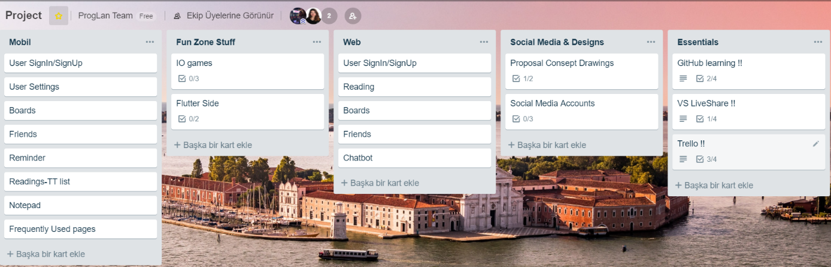

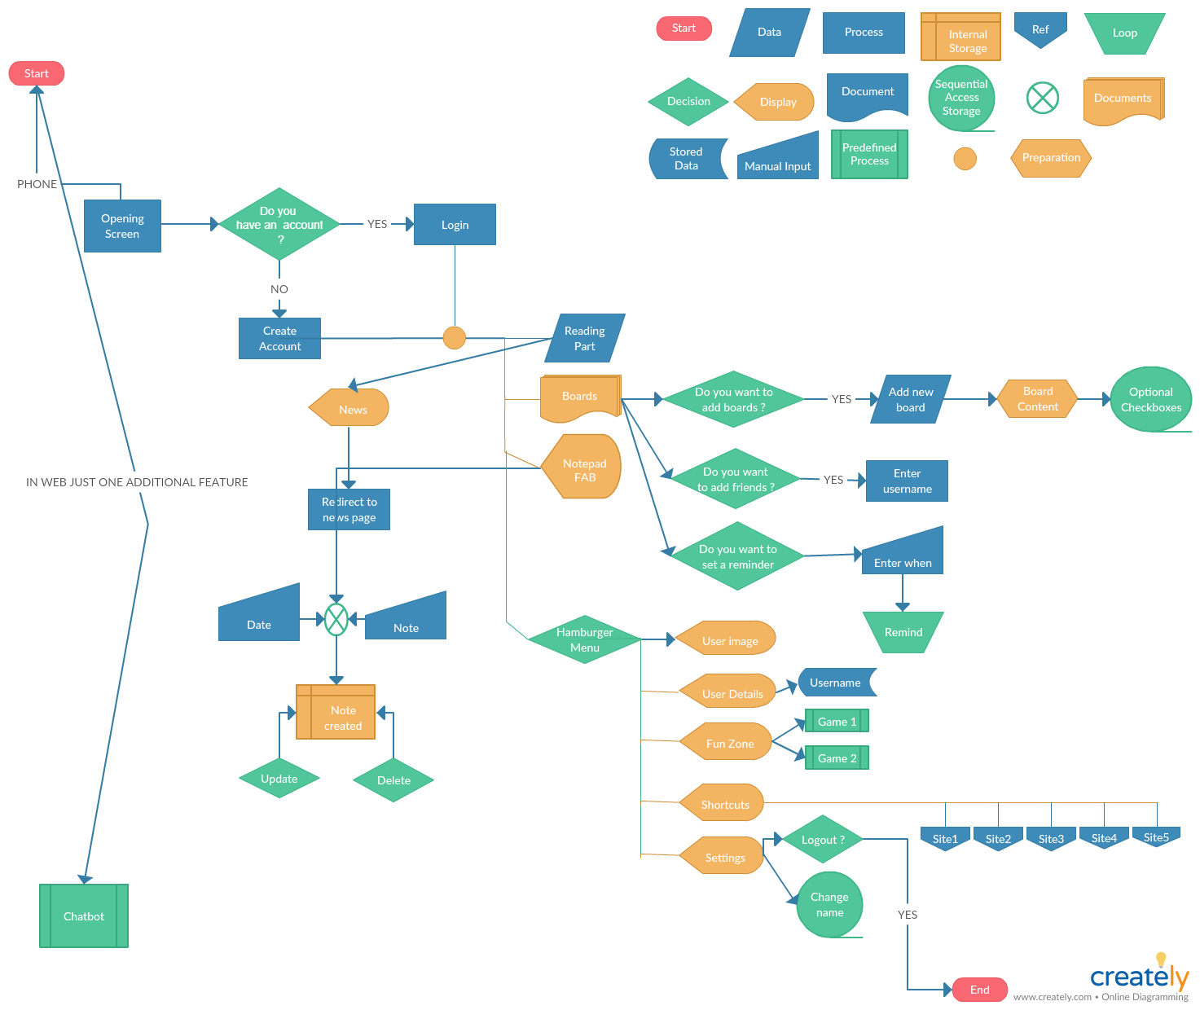

**Mobile App Pictures**

ekran görüntüsü içeren bir resim

Yüksek güvenilirlikle oluşturulmuş açıklama ekran görüntüsü içeren bir resim

Çok yüksek güvenilirlikle oluşturulmuş açıklama

ekran görüntüsü içeren bir resim

Çok yüksek güvenilirlikle oluşturulmuş açıklama ekran görüntüsü, yol içeren bir resim

Yüksek güvenilirlikle oluşturulmuş açıklama

ekran görüntüsü içeren bir resim

Çok yüksek güvenilirlikle oluşturulmuş açıklama

**WEB Platform**

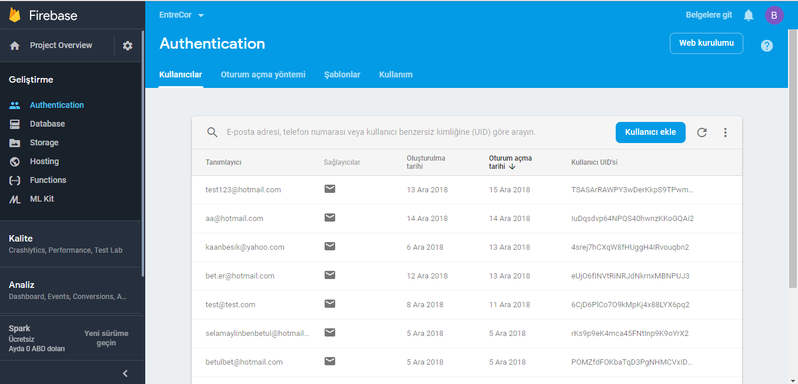

ekran görüntüsü içeren bir resim

Çok yüksek güvenilirlikle oluşturulmuş açıklama

ekran görüntüsü içeren bir resim

Çok yüksek güvenilirlikle oluşturulmuş açıklama